
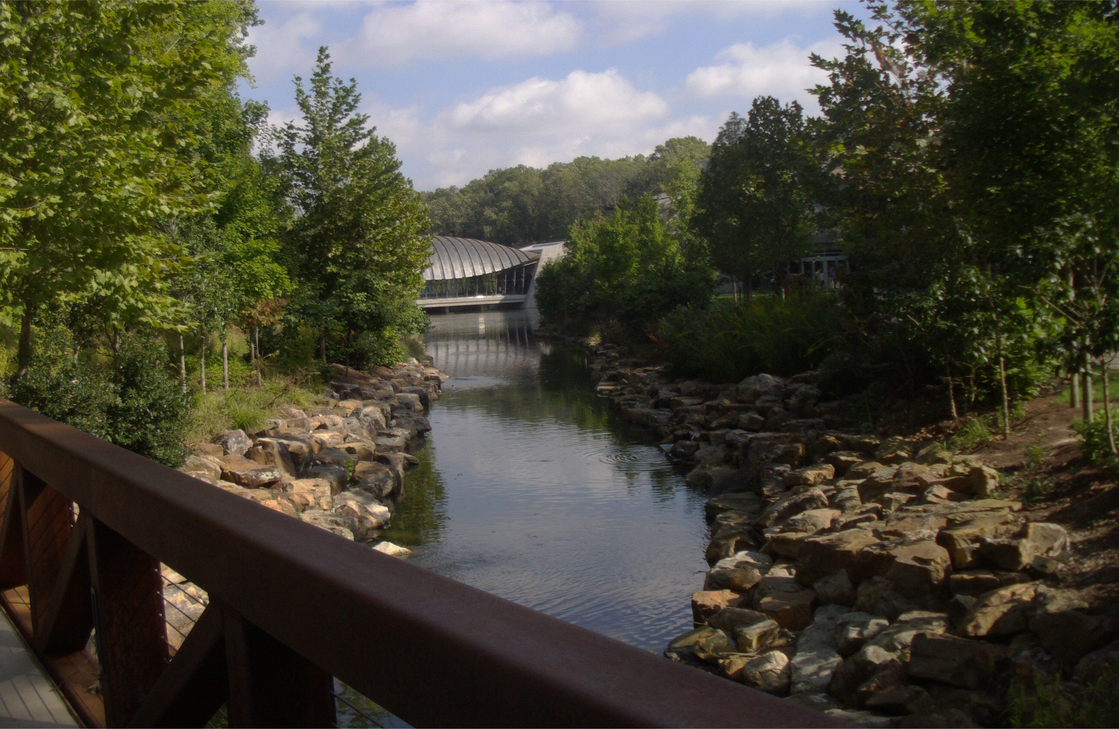
Entertainment Letter/Recipe Guide
Homegrown Producer, Will G. Louden™ Introduces two 30-minute

‘Dynamic & Interesting’ – Television Series!

Advertising / Broadcasting / and Production Information Inside
Homegrown
Spotlight: Talent, Success, Living & Lifestyle

Introducing:

Two NEW Broadcast Media Properties
“Abounding in Homegrown Charm”

Will G. Louden™ Presents
Geared towards the “Working Professional”

and

ClubRazor.com™
Geared towards the “18 to 35 Demographic”

Will G. Louden™ Host
& Executive Producer
™ Trademark & © Copyright 2014, WILLLOUDEN.COM, Inc.; WILL LOUDEN, LLC & Will G. Louden™ - LBR Trust. All Rights Reserved.
All other ™ Trademarks & © Copyrights are the property of their respective owners.

Sponsor Guide Contents:

Project Creator Memo2
General Project Terms3

Northwest Arkansas
Central Arkansas
Monroe/Mississippi
South Arkansas
Memphis/Jonesboro
Dallas/Ft Worth
New York “Big Apple”
Washington, DC
Los Angeles (Hollywood)
Boston
Houston
Tampa
Orlando
Chicago
Philadelphia
Atlanta
Phoenix
Minneapolis
Austin
Gainesville
Detroit
Charlotte
MIAMI
Startup Broadcast Markets:

ClubRazor.com™, lilroc.com™, nwaCafe.com™ and nwaliving.com™
Will G. Louden Presents
and ClubRazor.com

™

™


Greetings Beverage/Restaurant and/or Entertainment Venue:

I’m Will G. Louden™ (willglouden.com™), Little Rock native and spring 2005 graduate of the University of Arkansas, Sam M. Walton College of Business. I write to you today requesting submission of at least three unique recipes that are both reflective of your organization as well as symbolic of the healthier side of living!

Currently my team and I are in the process of producing two very dynamic and hip television series. “Will G. Louden™ Presents;” and “ClubRazor.com™,” are two separate 30-minute television series slated to air once a week all across Arkansas as well as several other top/key U.S. markets!

As a strategic part of this project I’ve written a history/background cookbook (dedicated to my beloved late mother) and I am inviting your establishment to participate by submitting at least three “original” recipes for eventual inclusion inside of my book. I’ll also give your establishment prime play in a new online national restaurant/entertainment/beverage network (online entertainment guide) that we’ll also launch in conjunction with these developing productions!!!

These television shows are designed to spotlight and promote community, hospitability, entertainment and FUN! Living & Lifestyle!!! We plan to tape shows ‘in studio’ as well as ‘on location’ to help deliver the highest product possible to the respective audiences.

Tentatively we are also planning on producing a makeshift launch tour and visit most IF not all of the core US cities where we are scheduled to begin broadcasting. Select establishments who elect to participate in this “cookbook phase” may also receive a special visit while we are out on tour and therefore also featured inside of one and/or more of our broadcast productions! Don’t worry IF your establishment is selected we’ll be sure and give you plenty of notice to get ready! :_)

While we are currently seeking local and national sponsors for the overall project underwriting the cost to you to participate in the cookbook/online entertainment destination phase is absolutely nothing! ZERO! Zilch! All we need is at least three “original” recipes and execution of a general project release agreement. That’s it! nothing more! For More information about me and the projects in general please visit: willlouden.com™ and/or willglouden.com™.

Thank you for your time and we sincerely hope to see you on board!

Sincerely,

Will G. Louden™
willglouden.com™

President: willlouden.com, Inc.
Online at: http://willlouden.com

clubrazor.com™, lilroc.com™, nwaCafe.com™, nwaliving.com™, willlouden.com™ and willglouden.com™ are all project affiliates

Notice: All intellectual property and copyrights are or will be the 100% property of either WILL LOUDEN, LLC, willlouden.com, Inc. and/or Will G. Louden™; Will G. Louden™ will host both television shows; Please Visit willlouden.com™ for more information.

Will is the owner and former publisher of Northwest Arkansas Living™ magazine, Northwest Arkansas Living Television™ and nwaliving.com™.

For more information and project details visit: lilroc.com™
Submission Form for the Three Recipes:

Will G. Louden™ Cookbook Project
Recipe/Submission & Guidelines:

Please provide recipes that are moderate to low in calories and provides some sort/degree of health and nutritional value for the reader. Submissions can also be made online by visiting willlouden.com™.

Submitted recipes can be: (1) a beverage, (2) breakfast, lunch and/or dinner dish, (3) dessert (pie, cake, smoothie, cookie, Sunday, etc. etc. etc.), (4) a late evening snack, and/or (5) an entertainment slider, etc. Submit prepared dish pictures IF you have them.

Recipe Number: _____ Recipe Name: ___________________ Recipe Type: ___________ Author & Business: ___________________________

Ingredients (please note calories/serving per ingredient as well as cost of individual ingredients and a suggested overall cost to produce/make recipe)

Preparation instructions and/or chef/cook notes etc.; Please also include all relevant oven, cook top and/or chilling temperatures, etc.

Serving instructions

Total number of adult servings (per completed dish) _______ | Calories per serving _______ | Fat Calories IF known _______

Emotional connection to the recipe IF there is one

Recipe Number: _____ Recipe Name: ___________________ Recipe Type: ___________ Author & Business: ___________________________

Ingredients (please note calories/serving per ingredient as well as cost of individual ingredients and a suggested overall cost to produce/make recipe)

Preparation instructions and/or chef/cook notes etc.; Please also include all relevant oven, cook top and/or chilling temperatures, etc.

Serving instructions

Total number of adult servings (per completed dish) _______ | Calories per serving _______ | Fat Calories IF known _______

Emotional connection to the recipe IF there is one

Recipe Number: _____ Recipe Name: ___________________ Recipe Type: ___________ Author & Business: ___________________________

Ingredients (please note calories/serving per ingredient as well as cost of individual ingredients and a suggested overall cost to produce/make recipe)

Preparation instructions and/or chef/cook notes etc.; Please also include all relevant oven, cook top and/or chilling temperatures, etc.

Serving instructions

Total number of adult servings (per completed dish) _______ | Calories per serving _______ | Fat Calories IF known _______

Emotional connection to the recipe IF there is one

™ Trademark & © Copyright 2014, WILLLOUDEN.COM, Inc. WILL LOUDEN, LLC & Will G. Louden™ - LBR Trust. All Rights Reserved. All other ™ Trademarks & © Copyrights are the property of their respective owners.



I. Television Shows:
Will G. Louden™ Presents AND ClubRazor.com™ are two separate 30-minute television programs/series broadcasting weekly all across Arkansas as well as select other key United States television markets.

The Will G. Louden™ Presents series will feature topics, segments and guests designed to draw a more mature and/or otherwise seasoned “working professional” audience; while the ClubRazor.com™ series will be designed and developed to cater specifically to the needs and viewing habits of the 18 to 35 year old coveted advertising demographic.

The programs will be produced/hosted by Little Rock , Arkansas native and University of Arkansas Sam M. Walton College of Business graduate, Will G. Louden™ (willglouden.com™). The estimated collective broadcast range of all stations involved at this point is 100+ million people.

II. Background Lifestyle Guide:
“HOMEGROWN,” will be a history/background healthy living and lifestyle guide book authored by Louden. The book will contain select recipes by Will as well as recipes that are submitted from select other sources including restaurants, beverage and entertainment establishments. Louden will also share a bit about his history, upbringing and business life.

III. Web Series:
All television programs and relevant media produced in conjunction with this project will also stream online for one year minimum AFTER their first run airdate on all of our perspective television station and broadcast media partners.

IV. Promotional Event(s):
Several pubic “ratings sweeps” events are planned to help kick up and create massive awareness for all aspects of the project(s), including several private VIP events which may also be held to help build additional ‘critical support’ for the developing project. The public events will be taped and included as a part of the broadcast series!
“Platinum Level” Terms of Sponsorship:

I) Television Give:
Includes 52 :30second TV spots
One feature segment (9 minutes); Show will air/broadcast at least once; Show will stream on web for 1 year; Show airings will be promoted “in newscast” by select project broadcast partners
One :30 second (optional) Will G. Louden™ product/brand endorsement

II) Web Series Give:
One online rotating banner ad; One online (optional) Will G. Louden™ product and/or brand endorsement ad

III) Lifestyle Guide Give:
One in book mention (on sponsors page)
In all first edition books
Online link for 1 year minimum
Full page ad inside of the book

IV) Events Give:
Name/logo: (1) online as event backer; (2) printed inside of the event program; (3) on the private VIP event invitation; & (4) on the media wall at the respective private VIP launch events
One 1/4th page ad inside of the 32-page (magazine like) event(s) program

ClubRazor.com™, lilroc.com™, nwaCafe.com™ and nwaliving.com™
™ Trademark & © Copyright 2014; WILLLOUDEN.COM, Inc. WILL LOUDEN, LLC & Will G. Louden™ - LBR Trust. All Rights Reserved. All other ™ Trademarks & © Copyrights are the property of their respective owners.

Will G. Louden™ Presents AND
ClubRazor.com™ Television Series
Sponsor Information

