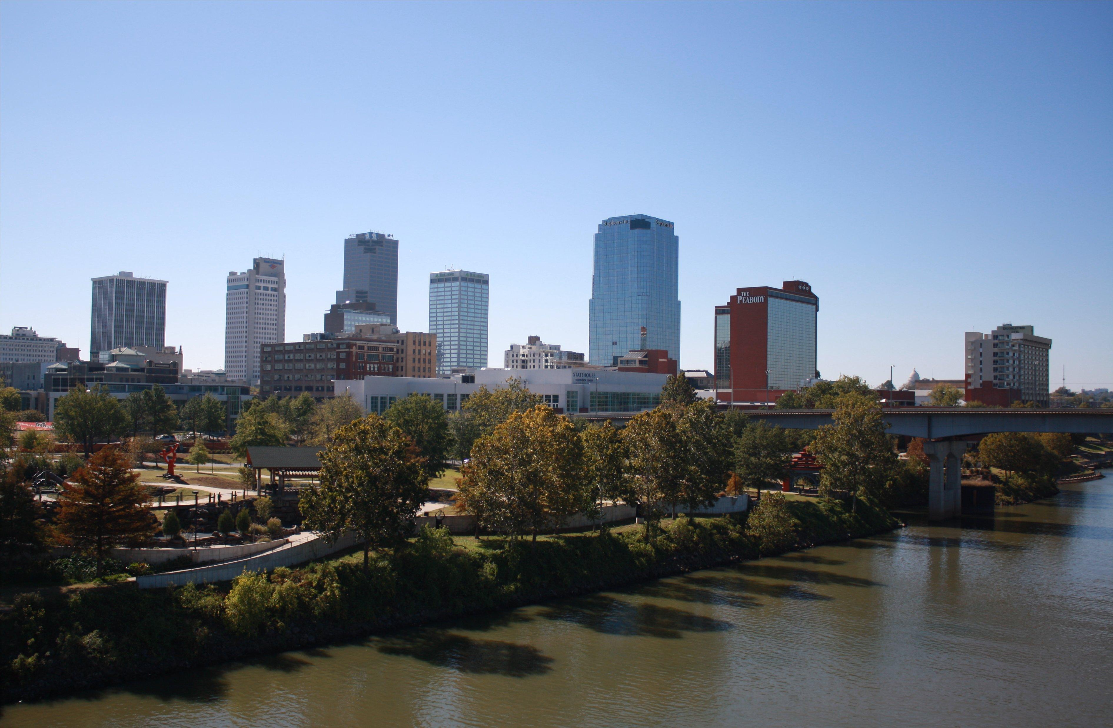
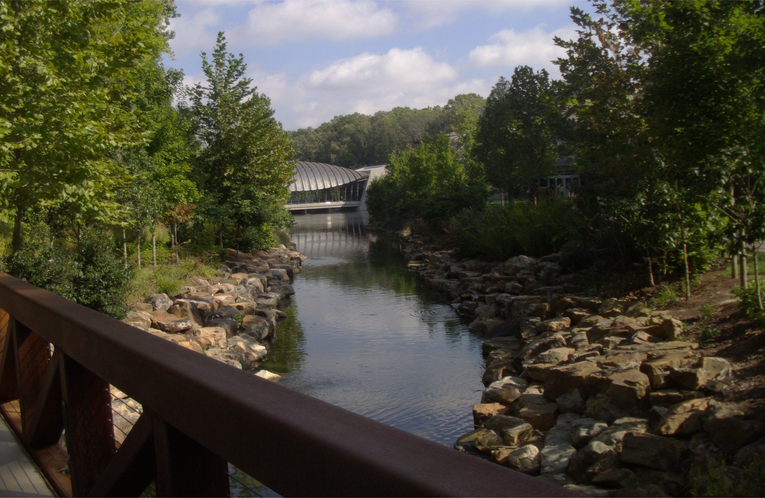
Platinum Level Sponsor Guide
Homegrown Producer, Will G. Louden™ Introduces two 30-minute

‘Dynamic & Interesting’ – Television Series!

Advertising / Broadcasting / and Production Information Inside

Northwest Arkansas
Central Arkansas
Monroe/Mississippi
South Arkansas
Memphis/Jonesboro
Dallas/Ft Worth
New York “Big Apple”
Washington, DC
Los Angeles (Hollywood)
Boston
Houston
Tampa
Orlando
Chicago
Philadelphia
Atlanta
Phoenix
Minneapolis
Austin
Gainesville
Detroit
Charlotte
San Francisco
MIAMI
Startup Broadcast Markets:

Sponsor Guide Contents:

Project Creator Memo 2
General Project Terms 3

Homegrown
Spotlight: Talent, Success, Living & Lifestyle

Introducing:

Two NEW Broadcast Media Properties
“Abounding in Homegrown Charm”

Will G. Louden™ Presents
Geared towards the “Working Professional”

and

ClubRazor.com™
Geared towards the “18 to 35 Demographic”

Will G. Louden™ Host
& Executive Producer

™ Trademark & © Copyright 2014, WILLLOUDEN.COM, Inc.; WILL LOUDEN, LLC & Will G. Louden™ - LBR Trust. All Rights Reserved.
All other ™ Trademarks & © Copyrights are the property of their respective owners.
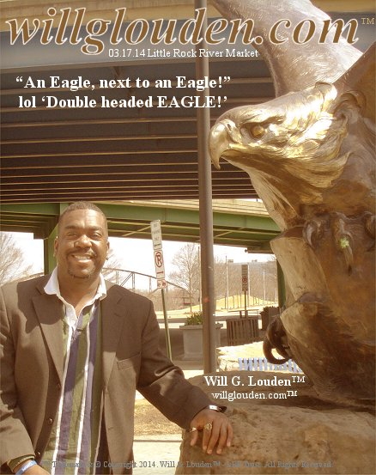
Greetings Prospective Platinum Level Sponsor:

I’m Will G. Louden™ (willglouden.com™), Little Rock native and spring 2005 graduate of the University of Arkansas, Sam M. Walton College of Business. I write to you today requesting sponsorship of four very dynamic project components that we are in the process of launching. “Will G. Louden™ Presents;” and “ClubRazor.com™,” are two separate 30-minute television series slated to air once a week all across Arkansas as well as several other top/key U.S. markets!

Right now our primary and startup broadcast partners are more than equipped and capable of reaching tens of millions of people; Full power broadcast range. I’m thankful to have their support and I also hope to gain yours!

This project will also encompass a history/background living and “lifestyle guide” dedicated to my beloved late mother, an online web series and several proposed all out “ratings sweeps” events. These additional components are all designed to help highlight and further promote the developing television series.

These television shows are designed to spotlight and promote community, hospitability, entertainment and FUN! Living & Lifestyle!!! We plan to tape shows ‘in studio’ as well as ‘on location’ to help deliver the highest product possible to the respective audiences.

Enclosed is a summary of “critical project components.” More information about me can be found online at willlouden.com™, and willglouden.com™.

Thank you for your time and we sincerely hope to gain your support!

Sincerely,

Will G. Louden™
willglouden.com™

President: willlouden.com, Inc.
Online at: http://willlouden.com
Will G. Louden Presents
and ClubRazor.com

clubrazor.com™, lilroc.com™, nwaCafe.com™, nwaliving.com™, willlouden.com™ and willglouden.com™ are all project affiliates

Notice: All intellectual property and copyrights are or will be the 100% property of either WILL LOUDEN, LLC, willlouden.com, Inc. and/or Will G. Louden™; Will G. Louden™ will host both television shows; Please Visit willlouden.com™ for more information.

ClubRazor.com™, lilroc.com™, nwaCafe.com™ and nwaliving.com™

™

™

Will is the owner and former publisher of Northwest Arkansas Living™ magazine, Northwest Arkansas Living Television™ and nwaliving.com™.

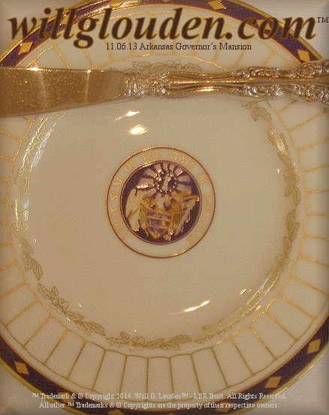

I. Television Shows:
Will G. Louden™ Presents AND ClubRazor.com™ are two separate 30-minute television programs/series broadcasting weekly all across Arkansas as well as select other key United States television markets.

The Will G. Louden™ Presents series will feature topics, segments and guests designed to draw a more mature and/or otherwise seasoned “working professional” audience; while the ClubRazor.com™ series will be designed and developed to cater specifically to the needs and viewing habits of the 18 to 35 year old coveted advertising demographic.

The programs will be produced/hosted by Little Rock , Arkansas native and University of Arkansas Sam M. Walton College of Business graduate, Will G. Louden™ (willglouden.com™). The estimated collective broadcast range of all stations involved at this point is 100+ million people.

II. Background Lifestyle Guide:
“HOMEGROWN,” will be a history/background healthy living and lifestyle guide book authored by Louden. The book will contain select recipes by Will as well as recipes that are submitted from select other sources including restaurants, beverage and entertainment establishments. Louden will also share a bit about his history, upbringing and business life.

III. Web Series:
All television programs and relevant media produced in conjunction with this project will also stream online for one year minimum AFTER their first run airdate on all of our perspective television station and broadcast media partners.

IV. Promotional Event(s):
Several pubic “ratings sweeps” events are planned to help kick up and create massive awareness for all aspects of the project(s), including several private VIP events which may also be held to help build additional ‘critical support’ for the developing project. The public events will be taped and included as a part of the broadcast series!
“Platinum Level” Terms of Sponsorship:

I) Television Give:
Includes 52 :30second TV spots
One feature segment (9 minutes); Show will air/broadcast at least once; Show will stream on web for 1 year; Show airings will be promoted “in newscast” by select project broadcast partners
One :30 second (optional) Will G. Louden™ product/brand endorsement

II) Web Series Give:
One online rotating banner ad; One online (optional) Will G. Louden™ product and/or brand endorsement ad

III) Lifestyle Guide Give:
One in book mention (on sponsors page)
In all first edition books
Online link for 1 year minimum
Full page ad inside of the book

IV) Events Give:
Name/logo: (1) online as event backer; (2) printed inside of the event program; (3) on the private VIP event invitation; & (4) on the media wall at the respective private VIP launch events
One 1/4th page ad inside of the 32-page (magazine like) event(s) program

ClubRazor.com™, lilroc.com™, nwaCafe.com™ and nwaliving.com™
™ Trademark & © Copyright 2014; WILLLOUDEN.COM, Inc. WILL LOUDEN, LLC & Will G. Louden™ - LBR Trust. All Rights Reserved. All other ™ Trademarks & © Copyrights are the property of their respective owners.

Will G. Louden™ Presents AND
ClubRazor.com™ Television Series
Sponsor Information

